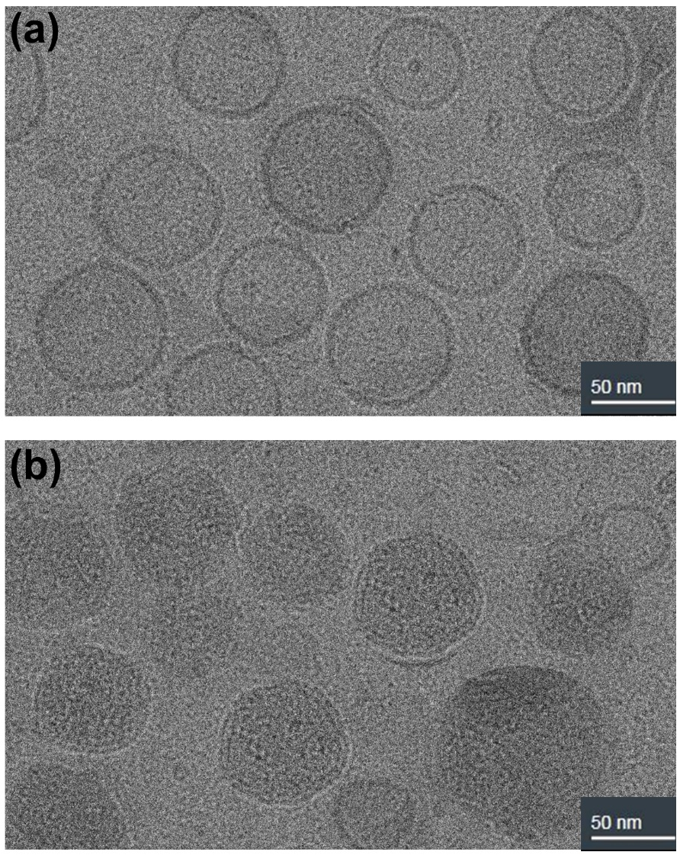
Figure 1. Representative cryo-TEM image from IAJD93-mRNA DNP in acetate buffer (a) blank IAJD93; (b) IAJD93-mRNA DNP.
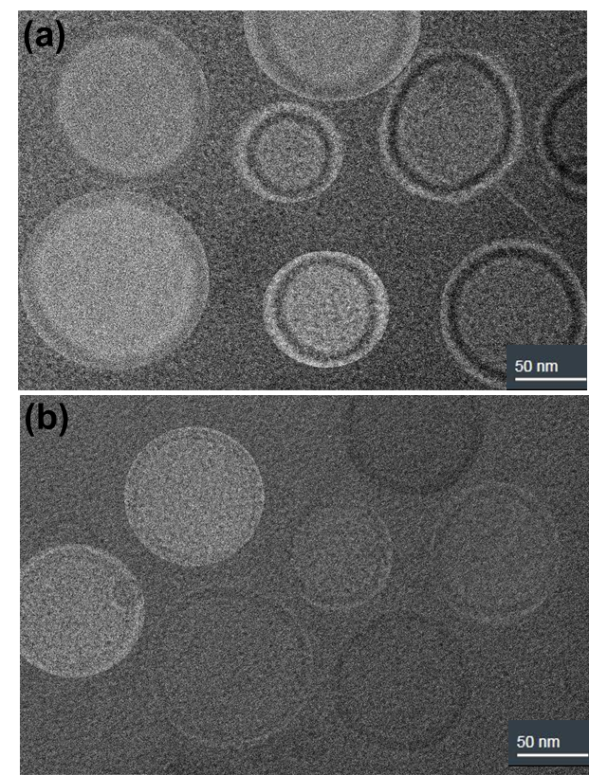
Figure 2. Representative cryo-TEM image of (a) IAJD97 in acetate buffer (pH = 4.0); (b) IAJD93 in acetate buffer (pH = 4.0).

